Sales Performance Analysis Report
Dashboard: Customer & Sales Analytics
Analysis Period: January - December
Total Sales: $2.3M | Total Profit: $286.4K | Profit Margin: 12.5%

Executive Summary
This comprehensive sales analysis dashboard provides actionable insights into customer behavior, product performance, geographical distribution, and operational efficiency across multiple segments. The analysis reveals strong performance indicators with a customer lifetime value of $2.90K and a remarkably low return rate of 0.08%.

1. Customer Performance Analysis

Key Metrics
- Total Customers: 793 unique customers
- Customer Lifetime Value (CLV): $2,900 per customer
- Customer Growth: Seasonal pattern with peak in November (1,505 customers)
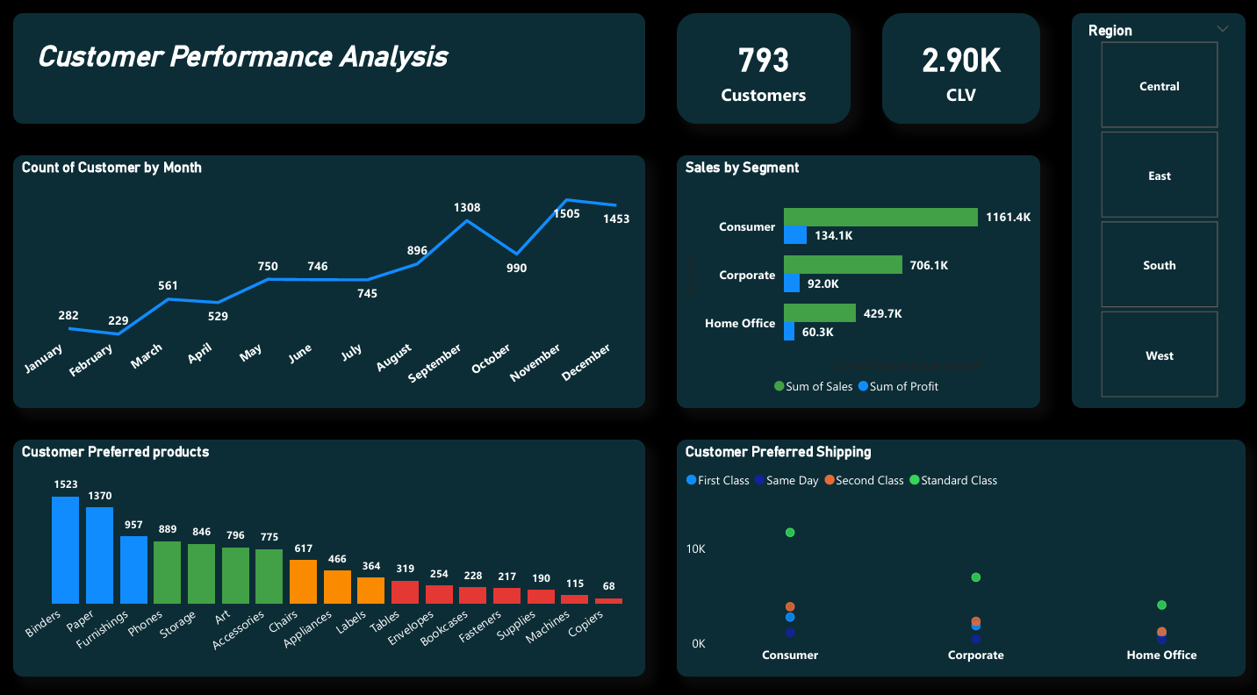

Customer Behavior Insights

Monthly Trends
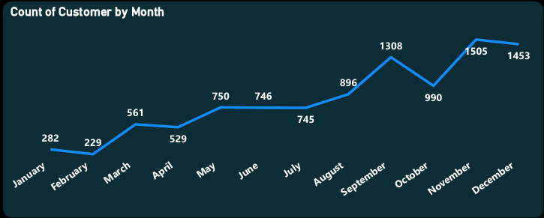
The customer acquisition shows significant seasonality with three distinct peaks:
- Q1 Growth: Steady increase from 282 (January) to 750 (May)
- Back-to-School Surge: Sharp increase in September (1,308 customers)
- Holiday Season Peak: Maximum customer count in November (1,505 customers)
The trend reveals:
- Lowest customer activity in February (229 customers)
- Steady growth through spring months
- Dramatic spike in fall season
- Slight decline in December (1,453) after November peak
Strategic Insight: The business demonstrates strong seasonality aligned with academic calendars and holiday shopping, suggesting opportunities for targeted marketing campaigns during these peak periods.

Product Preferences
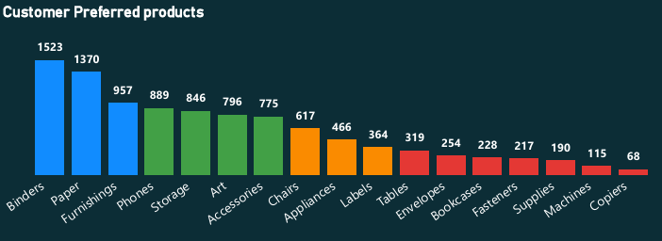
Top 5 preferred product categories:
- Binders: 1,523 units - Clear market leader
- Paper: 1,370 units - Essential office supply
- Furnishings: 957 units
- Phones: 889 units
- Storage: 846 units
Notable Findings:
- Office essentials (Binders, Paper, Storage) dominate customer preferences
- Technology items (Phones) show strong demand
- Lower-tier products (Copiers: 68 units) represent niche markets

Segment Performance
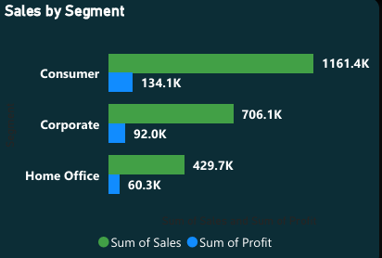

- Consumer Segment: $1,161.4K sales (50% market share) - Dominant force
- Corporate Segment: $706.1K sales (30% market share)
- Home Office: $429.7K sales (20% market share)
Profit Analysis by Segment:
- Consumer: $134.1K profit
- Corporate: $92.0K profit
- Home Office: $60.3K profit
The Consumer segment drives both volume and profitability, indicating strong B2C market positioning.

Shipping Analysis
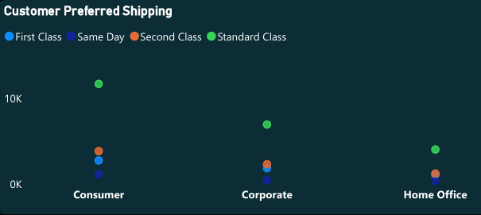
Customer shipping preferences indicate:
- Standard Class dominates across all segments (largest bubbles)
- First Class shipping preferred for higher-value orders
- Same Day delivery shows minimal usage (smallest bubbles), suggesting opportunity for premium service marketing or pricing adjustment
- Second Class shows moderate adoption
Shipping Insight: The preference for Standard Class across all customer segments suggests price sensitivity or satisfaction with standard delivery times.

2. Sales Representative & Operational Performance
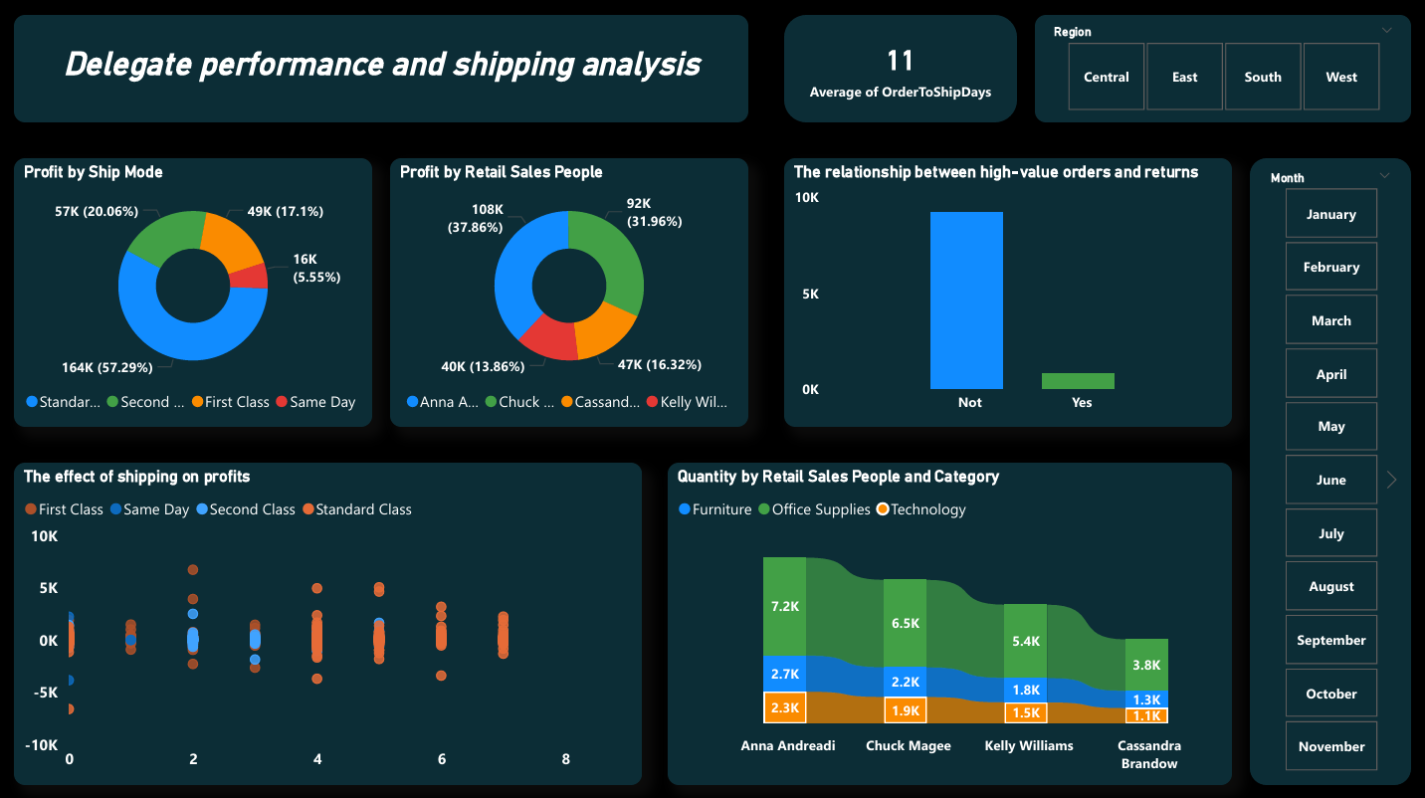

Profit Distribution by Sales Team
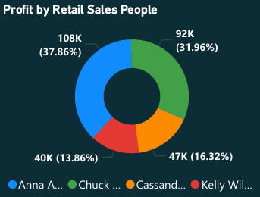
Top Performers:
- Anna Andreadi: $108K profit (37.86% contribution) - Top performer
- Chuck Magee: $92K profit (31.96%) - Strong secondary performer
- Kelly Williams: $47K profit (16.32%)
- Cassandra Brandow: $40K profit (13.86%)
Team Dynamics: The top two representatives (Anna and Chuck) account for nearly 70% of total profit, indicating either exceptional performance or unequal territory/account distribution that may need balancing.

Shipping Mode Profitability
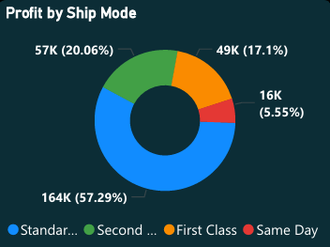
Profit by Ship Mode:
- Standard Class: $164K (57.29%) - Most profitable despite longer delivery
- First Class: $57K (20.06%)
- Second Class: $49K (17.1%)
- Same Day: $16K (5.55%) - Lowest profit contribution
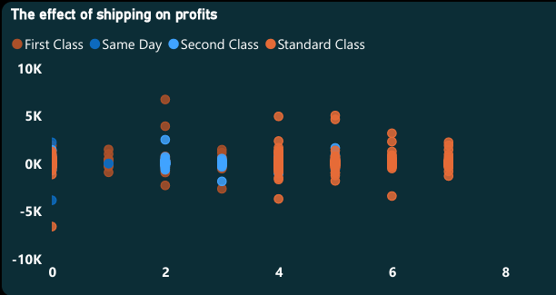
Key Finding: Standard shipping generates the highest profit despite longer delivery times. This suggests customers prioritize cost over speed, or that same-day premium pricing isn't competitive enough. The scatter plot reveals that shipping costs impact profitability across all modes, with Standard Class showing the most favorable cost-to-profit ratio.

Order Processing Efficiency

- Average Order-to-Ship Time: 11 days
- Assessment: This metric requires attention for competitive advantage in e-commerce
- Benchmark: Industry standards typically range from 2-5 days for standard shipping
Recommendation: Streamline fulfillment processes to reduce this time by 40-50% for improved customer satisfaction.

High-Value Order Analysis
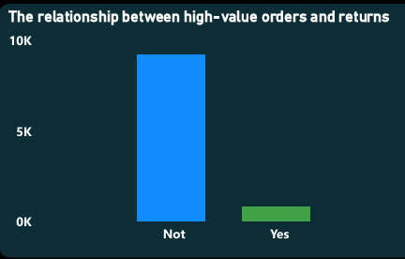
The relationship between high-value orders and returns shows:
- Orders marked as "Not" high-value show significantly higher volume (~10K orders)
- "Yes" high-value orders are fewer in quantity (~1K orders)
- Both categories show similar return patterns relative to order volume
Return Insight: High-value orders don't demonstrate disproportionately higher return rates, indicating good product-price alignment.

Category Performance by Representative
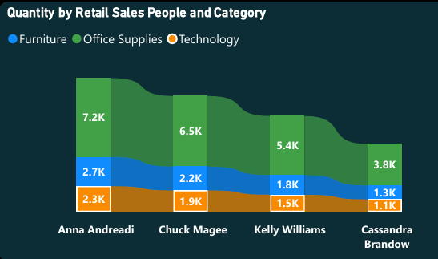
Product Mix Analysis:
- Anna Andreadi: Strong in Furniture (7.2K units) and Office Supplies (2.7K) - Diversified portfolio
- Chuck Magee: Balanced across categories with 6.5K Office Supplies leading
- Kelly Williams: Focus on Technology and Office Supplies (5.4K total units)
- Cassandra Brandow: Smaller volume (3.8K units) but consistent across categories
Sales Strategy: Anna's success with Furniture (highest-margin items) combined with high volume explains her profit leadership.

3. Geographical Analysis
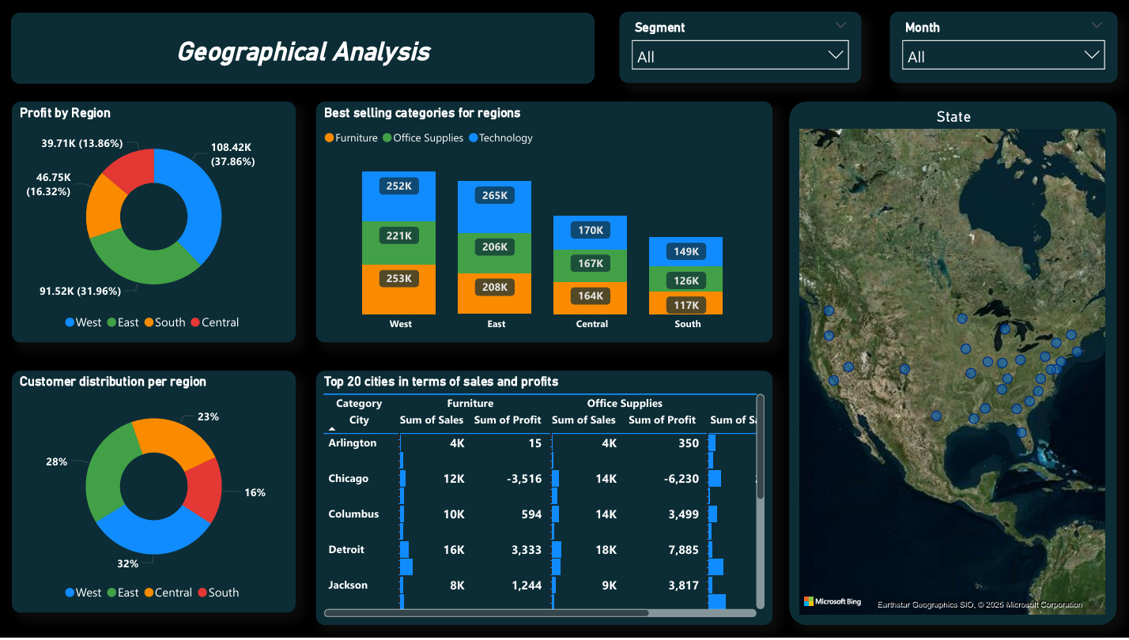

Regional Performance Overview
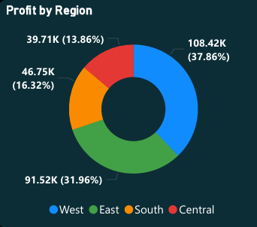
Profit by Region:
- West: $108.42K (37.86%) - Top performing region
- South: $91.52K (31.96%)
- East: $46.75K (16.32%)
- Central: $39.71K (13.86%)
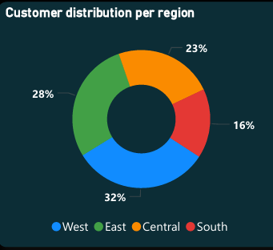
Customer Distribution:
- West: 32% of customers (252 customers)
- East: 28% of customers (222 customers)
- Central: 23% of customers (182 customers)
- South: 16% of customers (127 customers)
Important Insight: The West region achieves the highest profit (37.86%) with 32% of customers, indicating higher average order values or superior product mix. The South region shows impressive profit (31.96%) despite having the smallest customer base (16%), suggesting high-value customer concentration.

Geographic Distribution Visualization
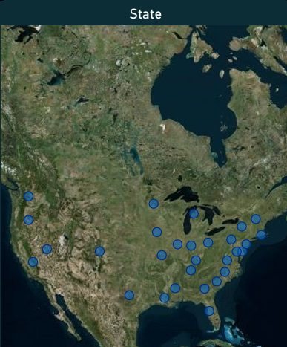
The map visualization shows comprehensive coverage across the United States with strong presence in:
- California and West Coast states
- Texas and Southern states
- Major metropolitan areas in East Coast
- Midwest coverage with room for expansion
Coverage Analysis: Dense clustering in coastal regions with opportunities to increase penetration in Mountain and Plains states.

Top Performing Cities
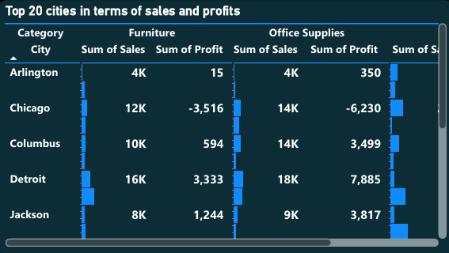
High-Performance Markets - Sample Cities:
Furniture Category Leaders:
- Arlington: $4K sales, $15 profit
- Burlington: $8K sales, $339 profit
- Chicago: $12K sales (negative profit: -$3,516) ⚠️
Office Supplies:
- Arlington: $4K sales, $350 profit
- Burlington: $4K sales (negative profit: -$651) ⚠️
- Chicago: $14K sales (negative profit: -$6,230) ⚠️
Technology:
- Arlington: $13K sales, $3,805 profit ⭐
- Burlington: $10K sales (negative profit: -$3,311) ⚠️
- Chicago: $22K sales, $3,092 profit
Total Performance:
- Overall: $394K sales, $7,203 profit (Furniture) | $370K sales, $53,869 profit (Office Supplies) | $526K sales, $96,158 profit (Technology)
Critical Finding: Chicago shows high sales volume but inconsistent profitability across categories, requiring urgent pricing or cost structure review. Burlington also shows concerning negative profits despite reasonable sales volume.

Regional Category Performance
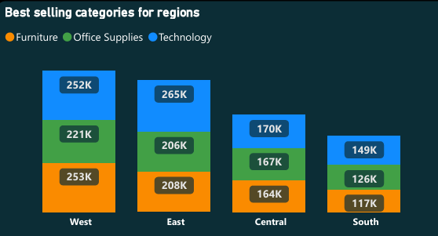
Best Selling Categories by Region:
- West:
  - Technology: $252K (leading category)
  - Furniture: $221K
  - Office Supplies: $253K
  - Total: ~$726K
- East:
  - Technology: $265K (highest tech sales across regions)
  - Furniture: $206K
  - Office Supplies: $208K
  - Total: ~$679K
- Central:
  - Technology: $170K
  - Office Supplies: $167K
  - Furniture: $164K
  - Total: ~$501K (most balanced mix)
- South:
  - Technology: $149K
  - Furniture: $149K
  - Office Supplies: $117K
  - Total: ~$415K
Regional Strategy: Technology performs consistently well across all regions, while Office Supplies show stronger performance in West and East coastal markets. Furniture sales are more evenly distributed.

4. Product & Profitability Analysis
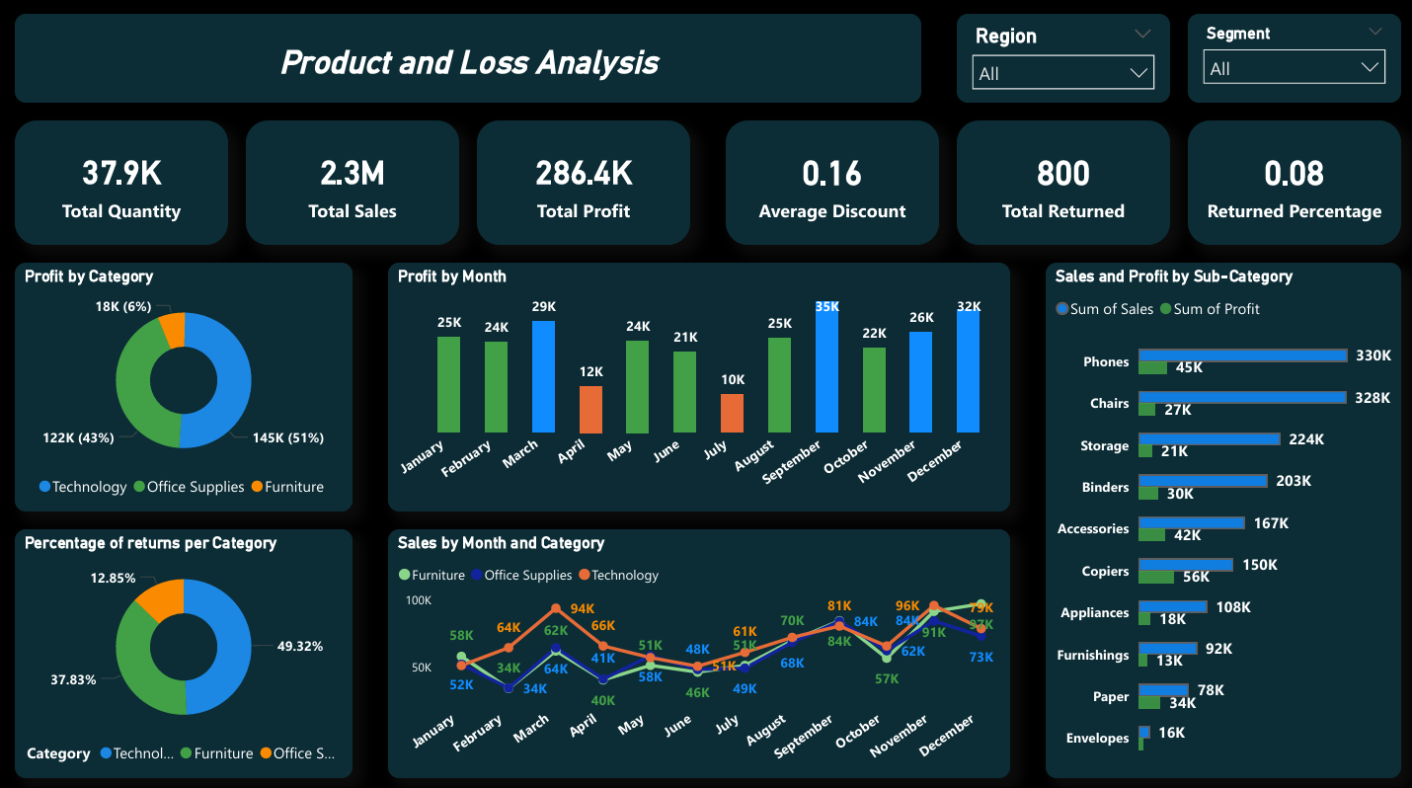

Overall Performance Metrics
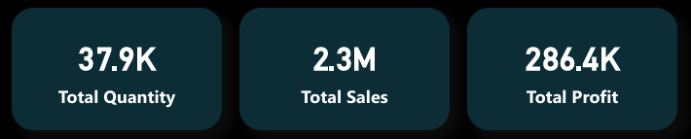
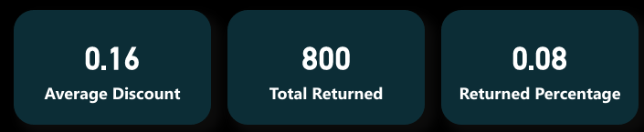
- Total Quantity Sold: 37,900 units
- Total Sales: $2.3M
- Total Profit: $286.4K (12.5% profit margin)
- Average Discount: 0.16 (16%)
- Total Returns: 800 units
- Return Rate: 0.08% (exceptionally low - industry benchmark is 2-5%)
Performance Assessment: The 12.5% profit margin is healthy for retail operations, while the 0.08% return rate is exceptional and indicates strong product quality and accurate product descriptions.

Category Profitability
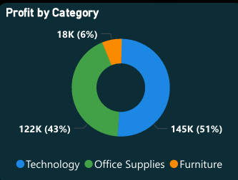
Profit by Category:
- Technology: $145K (51% of total profit) ⭐ Highest margin category
- Office Supplies: $122K (43%)
- Furniture: $18K (6%) ⚠️ Lowest margin despite high sales
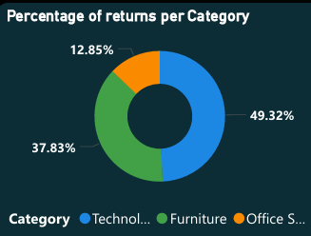
Return Rates by Category:
- Technology: 49.32% (of total returns, not of category sales)
- Office Supplies: 37.83%
- Furniture: 12.85% (lowest return rate)
Insight: While Technology has the highest return count, its high profitability (51%) more than compensates. Furniture's low return rate is positive but doesn't offset its low profit contribution.

Monthly Profit Trends
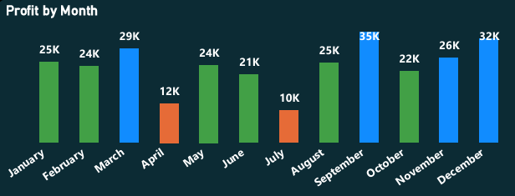
High-Performing Months:
- September: $35K profit + $25K sales (peak month)
- December: $32K profit + $26K sales (holiday season)
- March: $29K profit + $24K sales
- October: $22K profit + $25K sales
Low-Performing Months:
- April: $12K profit
- July: $10K profit (lowest month)
- February: $24K sales but only $24K profit
Seasonal Insight: Clear Q3 and Q4 strength, with mid-year (April-July) dip suggesting opportunity for promotional activities. The September spike likely correlates with back-to-school and fiscal year-end purchasing.

Sub-Category Performance
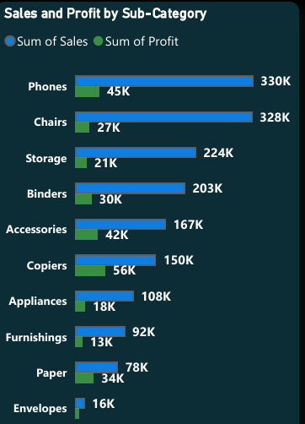
Top Revenue Generators:
- Phones: $330K sales, $45K profit (14% margin)
- Chairs: $328K sales, $27K profit (8% margin)
- Storage: $224K sales, $21K profit (9% margin)
- Binders: $203K sales, $30K profit (15% margin)
- Accessories: $167K sales, $42K profit (25% margin) ⭐
High-Margin Products (by profit %):
- Copiers: $150K sales, $56K profit (37% margin) ⭐⭐⭐ Champion
- Accessories: $167K sales, $42K profit (25% margin)
- Phones: $330K sales, $45K profit (14% margin)
- Binders: $203K sales, $30K profit (15% margin)
Low-Margin Products:
- Chairs: $328K sales, $27K profit (8% margin)
- Appliances: $108K sales, $18K profit (17% margin)
- Furnishings: $92K sales, $13K profit (14% margin)
Strategic Finding: Copiers represent the highest margin opportunity at 37%, despite moderate sales volume. Accessories also show exceptional margins (25%) and should be heavily promoted.

Category Sales Trends Over Time
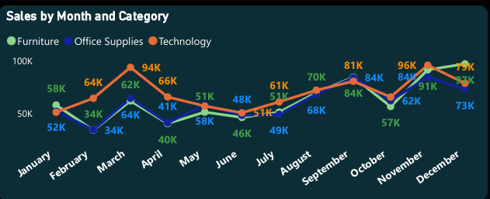
The line chart reveals seasonal patterns by category:
Technology (Orange line):
- Strongest performer with consistent growth
- Peak in November (~$100K)
- Relatively stable throughout year with gradual upward trend
- Shows least seasonality among categories
Furniture (Blue line):
- Steady performance around $50K-$75K monthly
- Moderate peaks in March and October
- More volatile than Technology
Office Supplies (Green line):
- Stable baseline between $40K-$70K monthly
- Sharp peak in September (~$95K) - back-to-school effect
- Most seasonal of the three categories
Strategic Finding: Technology shows the most consistent growth potential and should receive priority in marketing and inventory investment. Office Supplies demonstrate clear seasonality that can be leveraged with targeted campaigns.

Strategic Recommendations

1. Customer Acquisition & Retention
- Leverage Q4 momentum: Implement targeted campaigns in September-November to maximize seasonal peaks
- Address Q2 slowdown: Introduce mid-year promotions in April-July to balance annual performance
- CLV Optimization: With $2.9K CLV, focus on retention programs and loyalty initiatives for high-value customers
- Consumer Segment Focus: Double down on B2C marketing as it represents 50% of revenue

2. Product Strategy
- Technology Investment: As the profit leader (51%) with consistent growth, expand Technology product lines and inventory allocation
- Promote High-Margin Champions:
  - Copiers (37% margin) deserve premium positioning and targeted sales efforts
  - Accessories (25% margin) should be cross-sold with every order
  - Phones balance volume and margin effectively
- Furniture Margin Improvement: At only 6% profit contribution despite high sales, consider:
  - Reviewing supplier costs and pricing strategy
  - Introducing premium furniture lines with higher margins
  - Evaluating whether to continue low-margin Furniture items
- Reduce Low-Performers: Carefully evaluate continuation of Tables and low-margin Furnishings

3. Regional Expansion & Optimization
- West Region: Continue investment and replicate successful strategies as top performer
- South Region Opportunity: Despite smallest customer base (16%), achieves 32% profit - identify what's working and scale
- Central & East: Identify barriers to profitability growth and implement targeted regional marketing
- Chicago Market Crisis: Immediate action required to address significant losses across multiple categories:
  - Conduct pricing audit
  - Review shipping and logistics costs
  - Analyze competitive landscape
- Burlington Market: Similar profitability concerns requiring cost structure analysis

4. Operational Efficiency
- Shipping Optimization:
  - Reduce 11-day average shipping time to 5-7 days for competitive advantage
  - Continue prioritizing Standard Class shipping as primary offering given its 57% profit contribution
  - Re-evaluate Same Day pricing strategy - only 5.5% of profits suggests pricing too low or demand too limited
  - Consider discontinuing unprofitable express shipping if economics don't improve
- Return Rate Excellence: Maintain exceptional 0.08% rate through:
  - Continued quality control measures
  - Accurate product descriptions
  - Proper packaging standards
- Sales Team Development:
  - Provide additional resources and larger territories to top performers (Anna, Chuck)
  - Implement mentorship program where Anna/Chuck train Kelly and Cassandra
  - Analyze Anna's approach to Furniture sales for team-wide application

5. Pricing & Discounting
- Discount Strategy Review: At 16% average discount, conduct margin impact analysis:
  - Are discounts driving incremental volume that justifies margin erosion?
  - Test reducing discounts on high-demand items (Phones, Binders, Paper)
  - Reserve deeper discounts for slow-moving inventory
- Segment-Based Pricing: Implement differentiated discount structures:
  - Corporate: Volume-based tiering
  - Consumer: Promotional/seasonal discounts
  - Home Office: Bundle discounts
- Premium Service Testing: Test 25-30% premium pricing for same-day shipping given low current adoption
- Dynamic Pricing: Implement surge pricing during peak seasons (September, November, December)

6. Inventory Management
- Seasonal Stocking: Based on monthly trends, increase inventory:
  - August-September: +40% for back-to-school surge
  - October-December: +35% for holiday season
  - April-July: Reduce by 20% during slow periods
- Category Focus: Allocate inventory budget:
  - Technology: 50% (matches profit contribution)
  - Office Supplies: 35%
  - Furniture: 15% (or less, pending margin improvement)

7. Marketing & Sales Initiatives
- Back-to-School Campaign: Given September spike (1,308 customers, $35K profit), launch comprehensive campaign targeting education sector in August
- Holiday Promotion: Replicate November success (1,505 customers) with early-bird December campaigns
- Mid-Year Revival: Combat April-July slump with:
  - Flash sales on high-margin items (Copiers, Accessories)
  - "Summer Office Refresh" campaign
  - Bundle deals combining categories
- Cross-Selling Program: Technology + Accessories bundles to increase basket size
- Regional Campaigns: Tailor messaging by region based on category preferences

Conclusion
The sales performance analysis reveals a fundamentally healthy business with strong customer loyalty (CLV: $2.9K), exceptional quality control (0.08% returns), and clear profitability in Technology and Office Supplies categories. However, significant opportunities exist for improvement:
Immediate Priorities (Next 30 Days):
- Address Chicago and Burlington market profitability issues
- Reduce order-to-ship time from 11 to 7 days
- Launch high-margin product promotion (Copiers, Accessories)
Short-Term Goals (3-6 Months):
- Implement seasonal inventory and marketing strategies
- Review and optimize discount policy
- Expand Technology product offerings
- Scale West and South region success factors
Long-Term Strategic Initiatives (6-12 Months):
- Furniture category transformation or rationalization
- Sales team expansion and territory optimization
- Enhanced shipping options and partnerships
- Advanced customer segmentation and personalization
The dashboard effectively communicates these insights and provides a solid foundation for data-driven decision making. With focused execution on Technology expansion, operational efficiency improvements, and strategic regional development, achieving 20-25% profit growth in the next fiscal year is a realistic target.

